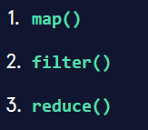

**map():**

- When called, *map()* applies the passed function to each and every element in the iterable and returns a map object  
- The returned map object holds the results from applying the mapping function to each element in the passed iterable – this will usually be converted to a list to enable further viewing/use 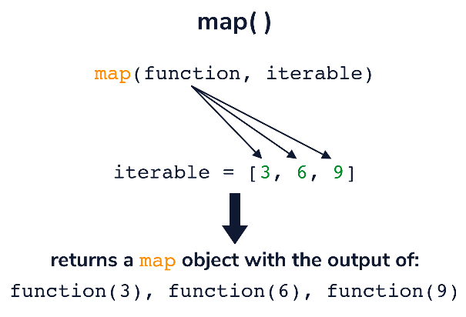



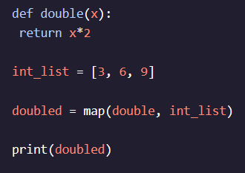







- Works especially well for *lambda functions* that don’t need to be resued anywhere else in code

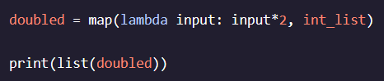

**filter():**

- Takes a function and an iterable as arguments and filters values out of it to determine if they exist in the iterable

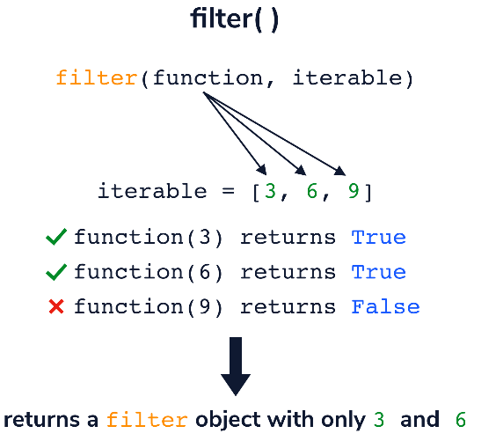

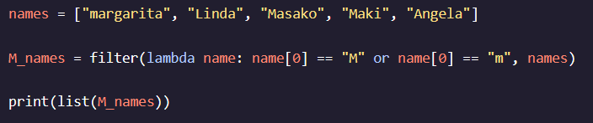  


**reduce():**

- Must be imported from the *functools* module to use it   
- Returns a single value instead of a reduce object

